SQL Project 1- (Case Study - Exploring Customer Behavior)

Data Summary:
CREATE DATABASE CustomerBehavior;

USE CustomerBehavior;
Table 1: Sales
CREATE TABLE Sales (
UserID INT,
Created_Date DATE,
Product_ID INT
);

INSERT INTO Sales (UserID) VALUES
(1),
(3),
(2),
(1),
(1),
(3),
(1),
(1),
(2),
(1),
(1),
(3),
(3),
(3),
(2),
(2),
(4),
(5),
(6),
(7),
(8),
(9),
(10),
(4),
(5),
(6),
(7),
(8),
(9);
ALTER TABLE Sales ADD SaleID INT IDENTITY(1,1);

;WITH vals (SaleID, dt) AS (
SELECT 1, '2017-04-19' UNION ALL
SELECT 2, '2019-12-18' UNION ALL
SELECT 3, '2020-07-20' UNION ALL
SELECT 4, '2019-10-23' UNION ALL
SELECT 5, '2018-03-19' UNION ALL
SELECT 6, '2016-12-20' UNION ALL
SELECT 7, '2016-11-09' UNION ALL
SELECT 8, '2016-05-20' UNION ALL
SELECT 9, '2017-09-24' UNION ALL
SELECT 10, '2017-03-11' UNION ALL
SELECT 11, '2016-03-11' UNION ALL
SELECT 12, '2016-11-10' UNION ALL
SELECT 13, '2017-12-07' UNION ALL
SELECT 14, '2016-12-15' UNION ALL
SELECT 15, '2017-11-08' UNION ALL
SELECT 16, '2018-09-10' UNION ALL
SELECT 17, '2019-05-01' UNION ALL
SELECT 18, '2018-11-23' UNION ALL
SELECT 19, '2017-06-30' UNION ALL
SELECT 20, '2018-08-12' UNION ALL
SELECT 21, '2019-03-19' UNION ALL
SELECT 22, '2017-12-04' UNION ALL
SELECT 23, '2018-09-22' UNION ALL
SELECT 24, '2020-08-17' UNION ALL
SELECT 25, '2017-05-12' UNION ALL
SELECT 26, '2014-01-27' UNION ALL
SELECT 27, '2014-04-02' UNION ALL
SELECT 28, '2020-12-15' UNION ALL
SELECT 29, '2017-09-08'
)
UPDATE s
SET Created_Date = v.dt
FROM Sales s
JOIN vals v ON s.SaleID = v.SaleID;

ALTER TABLE Sales DROP COLUMN tempid;

WITH cte AS (
SELECT Product_ID, ROW_NUMBER() OVER (ORDER BY (SELECT NULL)) AS rn
FROM (VALUES
(2),(1),(3),(2),(3),(2),(1),(3),(1),(2),
(1),(1),(2),(2),(2),(3),(1),(3),(9),(8),
(7),(6),(2),(1),(10),(11),(7),(8),(8)
) AS v(Product_ID)
)
UPDATE s
SET s.Product_ID = cte.Product_ID
FROM Sales s
JOIN cte ON s.SaleID = cte.rn;

ALTER TABLE Sales DROP COLUMN SaleID;

SELECT * FROM Sales;
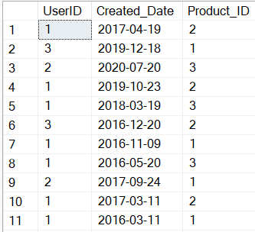
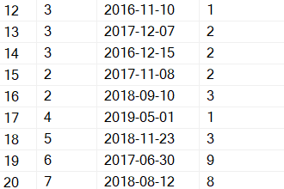
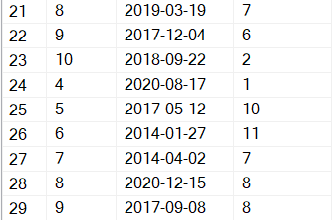

Table 2: Product
CREATE TABLE Product (
product_id INT PRIMARY KEY,
product_name VARCHAR(100),
price DECIMAL(10,2)
);

INSERT INTO Product (product_id) VALUES
(1),
(2),
(3),
(4),
(5),
(6),
(7),
(8),
(9),
(10),
(11);

UPDATE Product SET product_name = 'Dal Makani' WHERE product_id = 1;
UPDATE Product SET product_name = 'Shahi Panner' WHERE product_id = 2;
UPDATE Product SET product_name = 'Butter Chicken' WHERE product_id = 3;
UPDATE Product SET product_name = 'Aloo Gobi' WHERE product_id = 4;
UPDATE Product SET product_name = 'Chole Bhature' WHERE product_id = 5;
UPDATE Product SET product_name = 'Fish Curry' WHERE product_id = 6;
UPDATE Product SET product_name = 'Chicken Tikka' WHERE product_id = 7;
UPDATE Product SET product_name = 'Mutton Biryani' WHERE product_id = 8;
UPDATE Product SET product_name = 'Veg Pulao' WHERE product_id = 9;
UPDATE Product SET product_name = 'Mango Lassi' WHERE product_id = 10;
UPDATE Product SET product_name = 'Gulab Jamun' WHERE product_id = 11;

UPDATE Product SET price = 160 WHERE product_id = 1;
UPDATE Product SET price = 170 WHERE product_id = 2;
UPDATE Product SET price = 340 WHERE product_id = 3;
UPDATE Product SET price = 150 WHERE product_id = 4;
UPDATE Product SET price = 100 WHERE product_id = 5;
UPDATE Product SET price = 380 WHERE product_id = 6;
UPDATE Product SET price = 300 WHERE product_id = 7;
UPDATE Product SET price = 450 WHERE product_id = 8;
UPDATE Product SET price = 200 WHERE product_id = 9;
UPDATE Product SET price = 80 WHERE product_id = 10;
UPDATE Product SET price = 100 WHERE product_id = 11;
ALTER TABLE Product
ALTER COLUMN price INT;

SELECT * FROM Product;

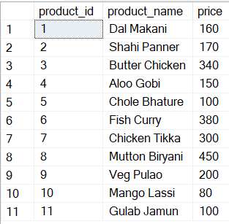
Table 3: User Name
CREATE TABLE User_Name (
userid INT PRIMARY KEY,
Names VARCHAR(100)
);

INSERT INTO User_Name (userid) VALUES
(1),
(2),
(3),
(4),
(5),
(6),
(7),
(8),
(9),
(10);

UPDATE User_Name SET Names = 'Anshul' WHERE userid = 1;
UPDATE User_Name SET Names = 'Rohan' WHERE userid = 2;
UPDATE User_Name SET Names = 'Shreya' WHERE userid = 3;
UPDATE User_Name SET Names = 'Priya' WHERE userid = 4;
UPDATE User_Name SET Names = 'Aryan' WHERE userid = 5;
UPDATE User_Name SET Names = 'Sara' WHERE userid = 6;
UPDATE User_Name SET Names = 'Sahil' WHERE userid = 7;
UPDATE User_Name SET Names = 'Tanvi' WHERE userid = 8;
UPDATE User_Name SET Names = 'Ritika' WHERE userid = 9;
UPDATE User_Name SET Names = 'Gaurav' WHERE userid = 10;

Select * from User_Name;
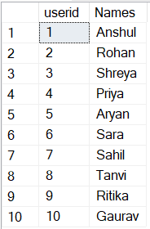

Table 4: Users
CREATE TABLE Users (
userid INT PRIMARY KEY,
signup_date DATE
);

INSERT INTO Users (userid) VALUES
(1),
(2),
(3),
(4),
(10),
(9),
(7),
(8),
(5),
(6);

UPDATE Users SET signup_date = '2014-09-02' WHERE userid = 1;
UPDATE Users SET signup_date = '2015-01-15' WHERE userid = 2;
UPDATE Users SET signup_date = '2014-04-11' WHERE userid = 3;
UPDATE Users SET signup_date = '2015-11-17' WHERE userid = 4;
UPDATE Users SET signup_date = '2016-01-02' WHERE userid = 10;
UPDATE Users SET signup_date = '2016-01-02' WHERE userid = 9;
UPDATE Users SET signup_date = '2013-04-02' WHERE userid = 7;
UPDATE Users SET signup_date = '2013-12-15' WHERE userid = 8;
UPDATE Users SET signup_date = '2015-09-08' WHERE userid = 5;
UPDATE Users SET signup_date = '2014-07-13' WHERE userid = 6;

Select * from Users;
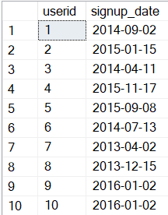
Table 5: Golduser_Signup
CREATE TABLE Golduser_Signup (
userid INT PRIMARY KEY,
gold_signup_date DATE
);

INSERT INTO Golduser_Signup (userid) VALUES
(1),
(2),
(3),
(4),
(10),
(9),
(7),
(8),
(5),
(6);

UPDATE Golduser_Signup SET gold_signup_date = '2017-05-15' WHERE userid = 1;
UPDATE Golduser_Signup SET gold_signup_date = NULL WHERE userid = 2; -- Not a gold member
UPDATE Golduser_Signup SET gold_signup_date = '2018-03-22' WHERE userid = 3;
UPDATE Golduser_Signup SET gold_signup_date = '2019-07-19' WHERE userid = 4;
UPDATE Golduser_Signup SET gold_signup_date = '2017-09-08' WHERE userid = 5;
UPDATE Golduser_Signup SET gold_signup_date = '2018-11-12' WHERE userid = 6;
UPDATE Golduser_Signup SET gold_signup_date = '2017-06-20' WHERE userid = 7;
UPDATE Golduser_Signup SET gold_signup_date = '2019-02-25' WHERE userid = 8;
UPDATE Golduser_Signup SET gold_signup_date = '2018-08-10' WHERE userid = 9;
UPDATE Golduser_Signup SET gold_signup_date = '2019-04-05' WHERE userid = 10;

Select * from Golduser_Signup;
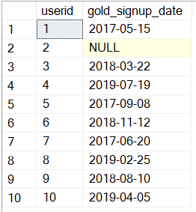
Q1. What is the total sales revenue generated by each product?
Ans: SELECT
p.product_name,
COUNT(s.product_id) AS total_units_sold,
p.price,
(COUNT(s.product_id) * p.price) AS total_revenue
FROM
Sales s
JOIN
Product p
ON
s.product_id = p.product_id
GROUP BY
p.product_name, p.price
ORDER BY
total_revenue DESC;
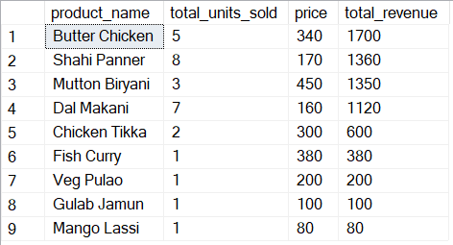
Q2. Which 3 product has the highest sales revenue?
Ans: SELECT TOP 3
p.product_name,
COUNT(s.product_id) AS total_units_sold,
p.price,
(COUNT(s.product_id) * p.price) AS total_revenue
FROM
Sales s
JOIN
Product p
ON
s.product_id = p.product_id
GROUP BY
p.product_name, p.price
ORDER BY
total_revenue DESC;
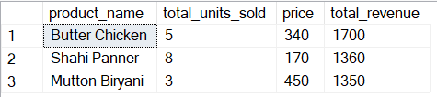
Q3. How many users have signed up for the service and has taken the gold membership?
Ans: SELECT
COUNT(*) AS total_gold_users
FROM
Users u
JOIN
Golduser_Signup g
ON
u.userid = g.userid
WHERE
g.gold_signup_date IS NOT NULL;
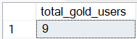
Q4. What is the revenue generated from gold users?
Ans: SELECT
SUM(p.price) AS GoldUser_Revenue
FROM
Sales s
JOIN
Product p ON s.Product_ID = p.Product_ID
JOIN
Golduser_Signup g ON s.UserID = g.UserID
WHERE
g.gold_signup_date IS NOT NULL;
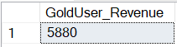
Q5. What is the total revenue generated from gold users?
Ans: SELECT
SUM(p.price) AS Total_GoldUser_Revenue
FROM
Sales s
JOIN
Product p ON s.Product_ID = p.Product_ID
JOIN
Golduser_Signup g ON s.UserID = g.UserID
WHERE
g.gold_signup_date IS NOT NULL;
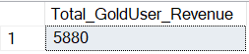
Q6. Which users has been a gold user for the How much of time?
Ans: SELECT
g.UserID,
u.signup_date,
g.gold_signup_date,
DATEDIFF(YEAR, g.gold_signup_date, GETDATE()) AS Years_as_GoldUser
FROM
Golduser_Signup g
JOIN
Users u ON g.UserID = u.UserID
WHERE
g.gold_signup_date IS NOT NULL;
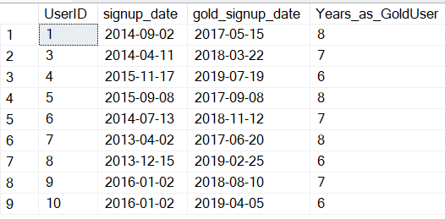
Q7. What is the most popular product among gold users?
Ans: SELECT
p.Product_ID,
p.Product_Name,
COUNT(*) AS Times_Purchased
FROM
Sales s
JOIN
Product p ON s.Product_ID = p.Product_ID
JOIN
Golduser_Signup g ON s.UserID = g.UserID
WHERE
g.gold_signup_date IS NOT NULL
GROUP BY
p.Product_ID, p.Product_Name
ORDER BY
Times_Purchased DESC;
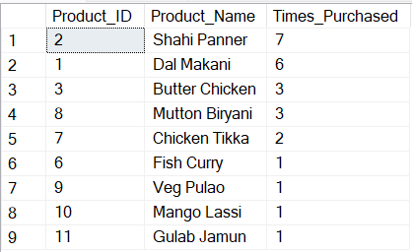
Q8. What is the total sales revenue generated in each year?
Ans: SELECT
YEAR(s.Created_Date) AS Sales_Year,
SUM(p.Price) AS Total_Revenue
FROM
Sales s
JOIN
Product p ON s.Product_ID = p.Product_ID
GROUP BY
YEAR(s.Created_Date)
ORDER BY
Sales_Year;
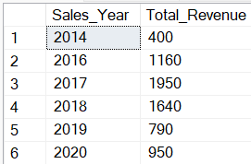
Q9. How has the sales revenue changed over the years?
Ans: WITH YearlyRevenue AS (
SELECT
YEAR(s.Created_Date) AS Sales_Year,
SUM(p.Price) AS Total_Revenue
FROM
Sales s
JOIN
Product p ON s.Product_ID = p.Product_ID
GROUP BY
YEAR(s.Created_Date)
)
SELECT
Sales_Year,
Total_Revenue,
LAG(Total_Revenue) OVER (ORDER BY Sales_Year) AS Previous_Year_Revenue,
(Total_Revenue - LAG(Total_Revenue) OVER (ORDER BY Sales_Year)) AS Revenue_Change,
ROUND(
(CAST(Total_Revenue - LAG(Total_Revenue) OVER (ORDER BY Sales_Year) AS FLOAT) /
LAG(Total_Revenue) OVER (ORDER BY Sales_Year)) * 100, 2
) AS Percentage_Change
FROM
YearlyRevenue
ORDER BY
Sales_Year;
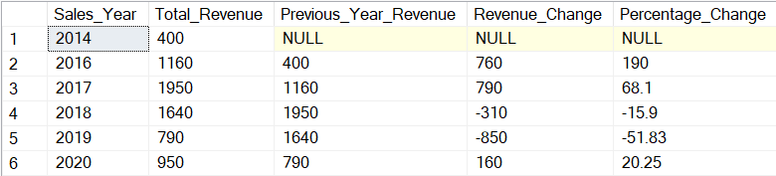
Q10. What is the average Gold-signup compare to just sign up for the users?
Ans: SELECT
AVG(DATEDIFF(DAY, u.signup_date, g.gold_signup_date)) AS Avg_Days_To_Gold,
COUNT(g.UserID) AS Gold_User_Count,
(SELECT COUNT(*) FROM Users) AS Total_User_Count
FROM
Users u
JOIN
Golduser_Signup g ON u.UserID = g.UserID
WHERE
g.gold_signup_date IS NOT NULL;
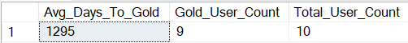
Q11. How many gold members users have order how many numbers of time?
Ans: SELECT
s.UserID,
COUNT(*) AS Total_Orders
FROM
Sales s
JOIN
Golduser_Signup g ON s.UserID = g.UserID
WHERE
g.gold_signup_date IS NOT NULL
GROUP BY
s.UserID
ORDER BY
Total_Orders DESC;
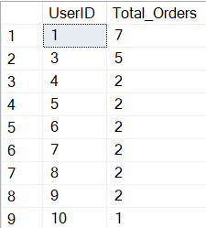
Q12. What is the total amount each customer spend on Online Food Delivery?
Ans: SELECT
s.UserID,
SUM(p.Price) AS Total_Spent
FROM
Sales s
JOIN
Product p ON s.Product_ID = p.Product_ID
GROUP BY
s.UserID
ORDER BY
Total_Spent DESC;
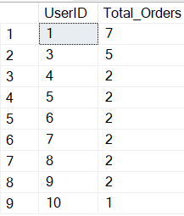

Q13. What is the frequency of customer visits to the online platform?
Ans: SELECT
s.UserID,
COUNT(*) AS Visit_Frequency
FROM
Sales s
GROUP BY
s.UserID
ORDER BY
Visit_Frequency DESC;
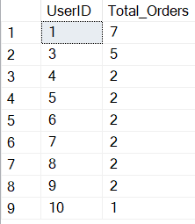
Q14. What was the first order purchase by each customer?
Ans: SELECT
s.UserID,
MIN(s.Created_Date) AS First_Order_Date
FROM
Sales s
GROUP BY
s.UserID
ORDER BY
s.UserID;
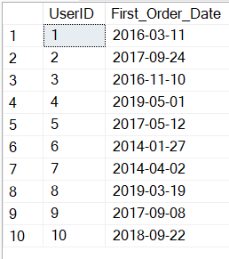
Q15. What is the most purchase item on the menu and how many times was it purchased by all customers?
Ans: SELECT
p.Product_ID,
p.Product_Name,
COUNT(*) AS Times_Purchased
FROM
Sales s
JOIN
Product p ON s.Product_ID = p.Product_ID
GROUP BY
p.Product_ID, p.Product_Name
ORDER BY
Times_Purchased DESC;
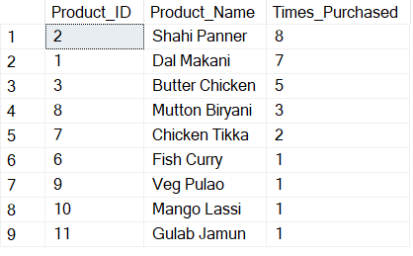
Q16. Which item was most popular for each customer?
Ans: WITH PurchaseCounts AS (
SELECT
s.UserID,
p.Product_Name,
COUNT(*) AS Times_Purchased
FROM
Sales s
JOIN
Product p ON s.Product_ID = p.Product_ID
GROUP BY
s.UserID, p.Product_Name
),
RankedPurchases AS (
SELECT
pc.*,
RANK() OVER (PARTITION BY pc.UserID ORDER BY pc.Times_Purchased DESC) AS rnk
FROM
PurchaseCounts pc
)
SELECT
rp.UserID,
u.Names AS Customer_Name,
rp.Product_Name,
rp.Times_Purchased
FROM
RankedPurchases rp
JOIN
User_Name u ON rp.UserID = u.UserID
WHERE
rp.rnk = 1
ORDER BY
rp.UserID;
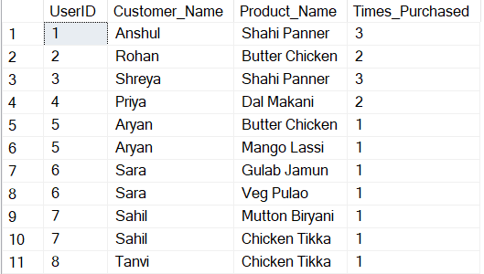
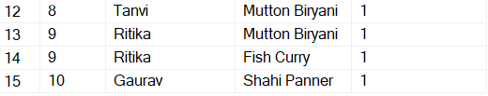
Q17. Which item was purchase first by the customer after they become a member?
Ans: SELECT
s.UserID,
u.Names AS Customer_Name,
p.Product_Name,
s.Created_Date AS First_Purchase_After_Gold
FROM
Sales s
JOIN
Product p ON s.Product_ID = p.Product_ID
JOIN
Golduser_Signup g ON s.UserID = g.UserID
JOIN
User_Name u ON s.UserID = u.UserID
WHERE
s.Created_Date = (
SELECT MIN(s2.Created_Date)
FROM Sales s2
WHERE s2.UserID = s.UserID
AND s2.Created_Date >= g.gold_signup_date
)
AND g.gold_signup_date IS NOT NULL
ORDER BY
s.UserID;
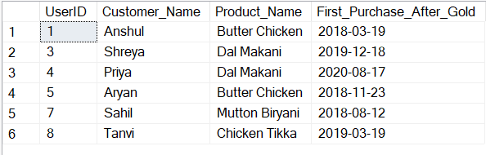
Q18.Which item was purchase before the customer become a member?
Ans: SELECT
s.UserID,
u.Names AS Customer_Name,
p.Product_Name,
s.Created_Date AS Last_Purchase_Before_Gold
FROM
Sales s
JOIN
Product p ON s.Product_ID = p.Product_ID
JOIN
Golduser_Signup g ON s.UserID = g.UserID
JOIN
User_Name u ON s.UserID = u.UserID
WHERE
s.Created_Date = (
SELECT MAX(s2.Created_Date)
FROM Sales s2
WHERE s2.UserID = s.UserID
AND s2.Created_Date < g.gold_signup_date
)
AND g.gold_signup_date IS NOT NULL
ORDER BY
s.UserID;
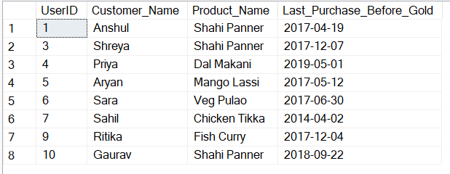
Q19. What is the total orders and amount spent for each member before they become a member?
Ans: SELECT
s.UserID,
u.Names AS Customer_Name,
COUNT(s.Product_ID) AS Total_Orders_Before_Gold,
SUM(p.Price) AS Total_Amount_Spent_Before_Gold
FROM
Sales s
JOIN
Product p ON s.Product_ID = p.Product_ID
JOIN
Golduser_Signup g ON s.UserID = g.UserID
JOIN
User_Name u ON s.UserID = u.UserID
WHERE
s.Created_Date < g.gold_signup_date
AND g.gold_signup_date IS NOT NULL
GROUP BY
s.UserID, u.Names
ORDER BY
Total_Amount_Spent_Before_Gold DESC;
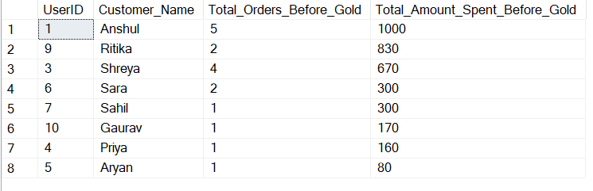
Q20. Rank all the transactions for each member whenever they are a XYZ gold member for every non gold member Transaction marks as na?
Ans: SELECT
s.UserID,
u.Names AS Customer_Name,
s.Product_ID,
p.Product_Name,
s.Created_Date,
g.gold_signup_date,
CASE
WHEN g.gold_signup_date IS NOT NULL
AND s.Created_Date >= g.gold_signup_date
THEN CAST(RANK() OVER (
PARTITION BY s.UserID
ORDER BY s.Created_Date
) AS VARCHAR(10))
ELSE 'NA'
END AS Gold_Member_Transaction_Rank
FROM
Sales s
JOIN
Product p ON s.Product_ID = p.Product_ID
JOIN
User_Name u ON s.UserID = u.UserID
LEFT JOIN
Golduser_Signup g ON s.UserID = g.UserID
ORDER BY
s.UserID, s.Created_Date;
